# VISVESVARAYA TECHNOLOGICAL UNIVERSITY BELAGAVI-590014



#### R Mini Project Report On

**House Price prediction using Machine Learning**

*A Project report submitted in partial fulfillment of the requirements for the IV Semester degree of*

***Bachelor of Engineering in Computer Science and Engineering***

*of Visvesvaraya Technological University, Belagavi*

#### Submitted by

**SAMARTH SRIVASTAVA (1DT21CS131)**

**SHIVAM ANAND (1DT21CS143)**

**SHUBHAM TULSYAN (1DT21CS147) SIDDHARTH KUMAR (1DT21CS148)**

**Under the Guidance of Mrs. Shilpa M**

Assistant Professor Computer Science and Engineering

Dayananda Sagar Academy of Technology & Management



**Department of Computer Science and Engineering**

**DAYANANDA SAGAR ACADEMY OF TECHNOLOGY AND MANAGEMENT**

Udayapura, Kanakapura Road, Bangalore-560082

2022-2023

# TABLE OF CONTENT

|  |  |  |
| --- | --- | --- |
| **SL. NO** | **PARTICULARS** | **PAGE NO** |
| 1 | ABSTRACT | 1 |
| 2 | INTRODUCTION | 2 – 3 |
| 3 | CODE | 4 – 6 |
| 4 | FLOW CHART | 7 |
| 5 | OBSERVED OUTPUT | 8 |
| 6 | OUTPUT SCREENSHOTS | 9 |
| 7 | CONCLUSION | 10 |
| 8 | REFERENCES | 11 |

**ABSTRACT**

Text mining is a powerful technique in data analysis that involves extracting valuable information and insights from textual data. In this report, we explore the use of R programming for text mining, discussing its importance, methods, and practical applications. We provide an introduction to text mining, highlighting its relevance in today's data-driven world.

R packages like 'tm', 'tidytext', 'topicmodels', and 'quanteda' are utilized for data preprocessing, feature extraction, and model building. Sentiment analysis tools help in understanding the emotional tone of the text, while topic modeling reveals the underlying themes and subjects. Named entity recognition identifies and categorizes important entities like names, locations, and organizations within the text.

Through this project, valuable insights are gained from the analyzed text data, which can be used for various applications such as market research, customer feedback analysis, and content recommendation systems. The power of R in text mining is demonstrated, showcasing its ability to handle and extract knowledge from vast amounts of unstructured textual information.

**INTRODUCTION**

In today's digital age, vast amounts of textual data are generated daily, ranging from social media posts and customer reviews to scientific articles and business documents. This proliferation of text data presents a unique opportunity to extract valuable information and insights from unstructured text. Text mining, also known as text analytics or natural language processing (NLP), is the process of converting unstructured text into structured data for analysis and interpretation.

R programming has emerged as a powerful tool for text mining due to its extensive libraries and packages tailored to NLP tasks. In this report, we will delve into the world of text mining in R, exploring its significance and practical applications.

**Importance of Text Mining**

Text mining holds immense importance in various domains, including:

1. **Business Intelligence**: Organizations can analyze customer feedback, social media posts, and online reviews to understand customer sentiment and make informed decisions regarding product development and marketing strategies.
2. **Healthcare**: Medical professionals can extract valuable insights from electronic health records (EHRs) to enhance patient care, identify trends, and predict disease outbreaks.
3. **Finance**: Financial institutions can analyze news articles, earnings reports, and financial statements to assess market sentiment and make investment decisions.
4. **Academic Research**: Researchers can analyze scientific articles, patents, and academic papers to identify emerging trends and conduct literature reviews more efficiently.
5. **Legal Industry**: Legal professionals can perform eDiscovery and contract analysis to streamline legal document review processes.

**Text Mining in R**

R programming offers a comprehensive ecosystem for text mining, with several essential packages:

1. **tm (Text Mining)**: The tm package provides a framework for text preprocessing, transformation, and analysis. It includes functions for text cleaning, tokenization, and term-document matrix creation.
2. **SnowballC**: Snowball Stemmers Based on the C 'libstemmer' UTF-8 Library. An R interface to the C 'libstemmer' library that implements Porter's word stemming algorithm for collapsing words to a common root to aid comparison of vocabulary.
3. **NLP**: The NLP package provides various natural language processing functionalities, including part-of-speech tagging, stemming, and lemmatization.
4. **ggplot2**: It includes themes for personalizing charts. With the theme function components, the colours, line types, typefaces, and alignment of the plot can be changed, among other things. Various options allow you to personalize the graph by adding titles, subtitles, arrows, texts, or lines.
5. **wordcloud2**: It is a visual representation of text data. The size of each word indicates its frequency or importance. In R, you can create word clouds using the wordcloud package.

**PROGRAM CODE**

#Initial Code

{

  #Start

  {

  #install.packages('tm')

  library(tm)

  docs<- Corpus(DirSource('Base2/'))

  toSpace <- content_transformer(function(x, pattern) {return(gsub(pattern, " ",x))})

  docs <- tm_map(docs, toSpace, "-")

  docs <- tm_map(docs, toSpace, ":")

  docs <- tm_map(docs, toSpace, "'")

  docs <- tm_map(docs, toSpace, '"')

  docs <- tm_map(docs, toSpace, " -")

  docs<- tm_map(docs, removePunctuation)

  docs <- tm_map(docs,content_transformer(tolower))

  docs <- tm_map(docs, removeNumbers)

  docs <- tm_map(docs, removeWords, stopwords("english"))

  docs <- tm_map(docs, stripWhitespace)

}

  #Streaming

  {

  #install.packages('SnowballC')

  library(SnowballC)

  docs <- tm_map(docs, content_transformer(gsub), pattern = "activity", replacement ="active")

  docs <- tm_map(docs, content_transformer(gsub), pattern = "ting", replacement ="te")

  docs <- tm_map(docs, content_transformer(gsub), pattern = "ning", replacement ="n")

  docs <- tm_map(docs, content_transformer(gsub), pattern = "stories", replacement ="story")

  docs <- tm_map(docs,stemDocument)

  docs <- tm_map(docs, content_transformer(gsub), pattern = "challeng", replacement ="challenge")

  docs <- tm_map(docs, content_transformer(gsub), pattern = "creativ", replacement ="creative")

  docs <- tm_map(docs, content_transformer(gsub), pattern = "stori", replacement ="story")

  docs <- tm_map(docs, content_transformer(gsub), pattern = "easi", replacement ="easy")

  docs <- tm_map(docs, content_transformer(gsub), pattern = "forc", replacement ="force")

  docs <- tm_map(docs, content_transformer(gsub), pattern = "undertaken", replacement ="undertake")

  docs <- tm_map(docs, content_transformer(gsub), pattern = "websit", replacement ="website")

  docs <- tm_map(docs, content_transformer(gsub), pattern = "comput", replacement ="computer")

  docs <- tm_map(docs, content_transformer(gsub), pattern = "electr", replacement ="electric")

  docs <- tm_map(docs, content_transformer(gsub), pattern = "messag", replacement ="message")

  docs <- tm_map(docs, content_transformer(gsub), pattern = "devic", replacement ="device")

  docs <- tm_map(docs, content_transformer(gsub), pattern = "amaz", replacement ="amaze")

  docs <- tm_map(docs, content_transformer(gsub), pattern = "outsid", replacement ="outside")

}

  #Removing rare words

  {

  dtm <- DocumentTermMatrix(docs)

  freq <- colSums(as.matrix(dtm))

  ord <- order(freq, decreasing=TRUE)

  dtmr <-DocumentTermMatrix(docs, control=list(wordlengths=c(4,20), bounds = list(global = c(2,27))))

  freqr = colSums(as.matrix(dtmr))

  ordr <- order(freqr, decreasing = TRUE)

  print("Words with frequency greater then 7")

  findFreqTerms(dtmr,lowfreq=7)

}

}

#correlations of Common Word

{

  print(findAssocs(dtmr, "computer" , 0.7))

  print(findAssocs(dtmr,"data",0.7))

  print(findAssocs(dtmr,"device",0.7))

}

#Histogram

{

  library(ggplot2)

  dtma <-DocumentTermMatrix(docs, control=list(wordlengths=c(2,20), bounds = list(global = c(5,27))))

  m <- as.matrix(dtma)

  m

  Frequency <- sort(colSums(as.matrix(dtma)), decreasing=TRUE)

  wf <- data.frame(Words=names(Frequency), freq=Frequency)

  p <- ggplot(subset(wf, Frequency>1), aes(Words, Frequency))

  p <- p + geom_bar(stat="identity")

  p <- p + theme(axis.text.x=element_text(angle=45, hjust=1))

  p

}

#Word Cloud

{

  library(wordcloud)

  set.seed(42)

  wordcloud (names(freqr), freqr,min.freq=6,colors=brewer.pal (6, "Dark2"))

}

**FLOW CHART**

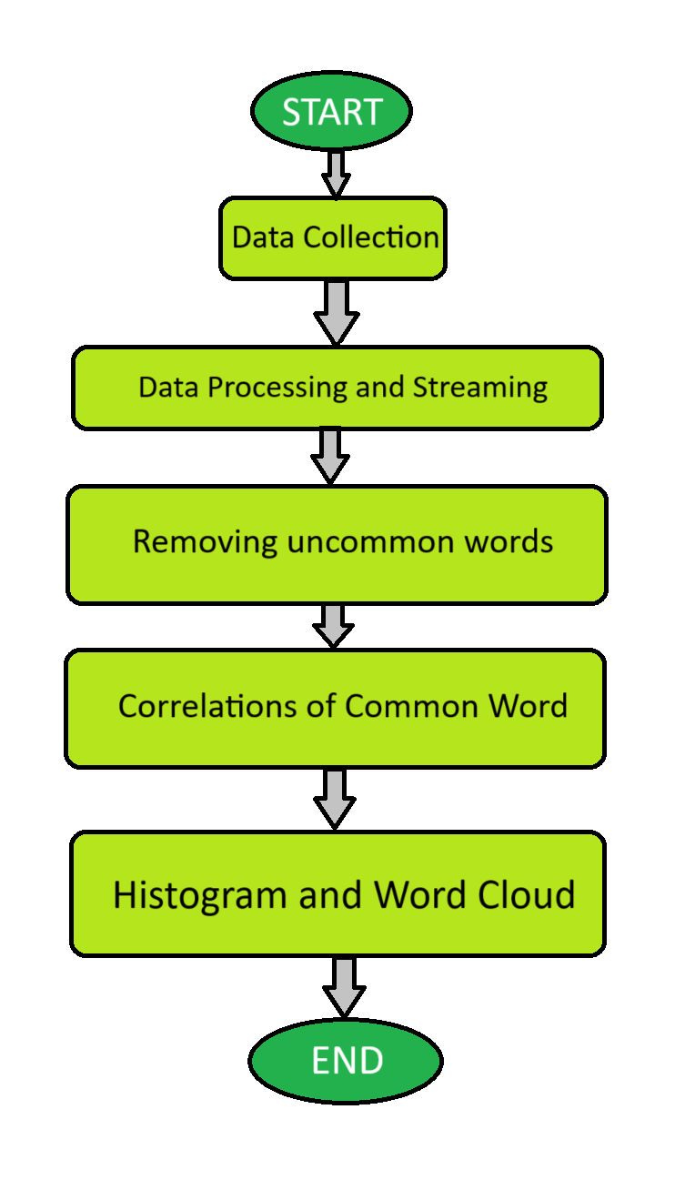**OBSERVED OUTPUTS**



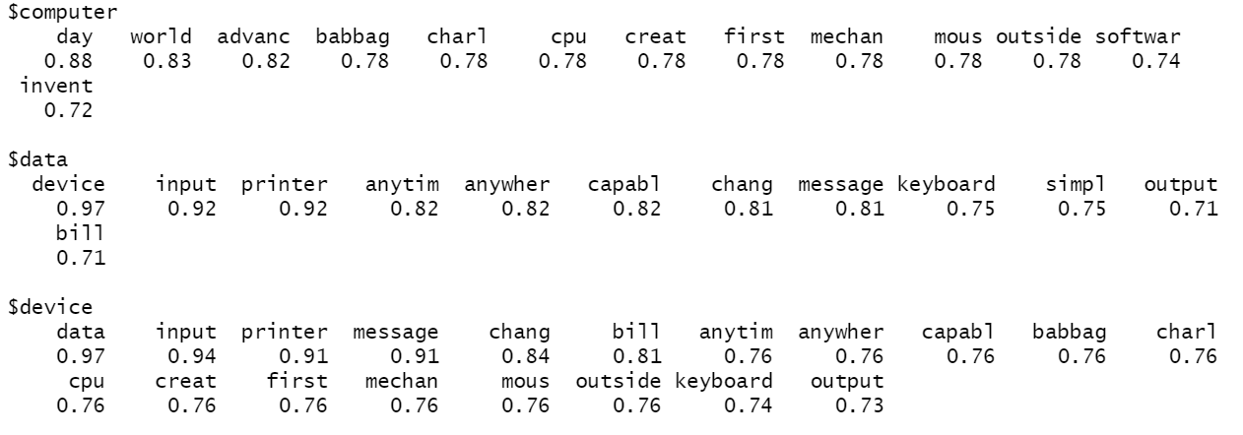

**OUTPUT SCREENSHOTS**

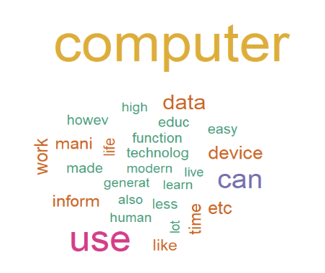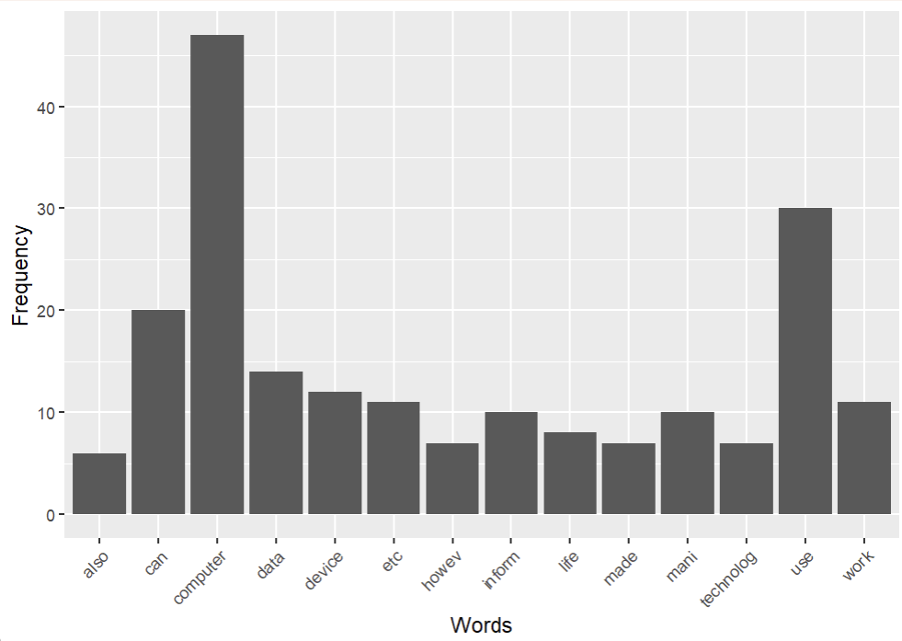

**CONCLUSION**

The conclusion of a text mining project using R should summarize the key findings, insights, and implications of your analysis. Here's a general structure for a conclusion in a text mining project using R:

Summary of the Project: Begin by briefly summarizing the purpose and scope of your text mining project. Mention the data source, the objectives, and the techniques used.

Data Preprocessing: Discuss the importance of data preprocessing in text mining and highlight the steps you took to clean, preprocess, and prepare your text data. This might include tasks like tokenization, stemming, stop-word removal, and handling missing data.

Exploratory Data Analysis (EDA): Share any interesting observations or patterns you discovered during the EDA phase. Mention any visualizations or statistical analyses that helped you understand the text data better.

Text Mining Techniques: Explain the specific text mining techniques or algorithms you used in your project. This could include techniques like topic modeling (e.g., LDA), sentiment analysis, text classification (e.g., using machine learning algorithms like Naive Bayes or SVM), or word embeddings (e.g., Word2Vec or GloVe).

**REFERENCES**

1. Books:

* "R for Data Science" by Hadley Wickham and Garrett Grolemund.

1. Online Tutorials and Documentation:

* R Project's official website : <https://www.r-project.org/>
* W3schools : <https://www.w3schools.com/>
* Geeksforgeeks : <https://practice.geeksforgeeks.org/>

1. Forums and Q&A:

* Stack Overflow : <https://stackoverflow.com/>
* RStudio Community : <https://community.rstudio.com/>